Smart IoT Access Control System
(Graduation Project 1,2 or semester project) prepared to obtain the degree of B.Sc. in the Department of Artificial Intelligence Engineering and Data Science

Authors:
Rafah Kaddour
Supervised by:
Dr Rawad Melhem
Eng Oday Abbas

Damascus:$\frac{هـ1447-1448}{م 2025-2026}$

SUPERVISOR CERTIFICATION

I certify that the preparation of this project, entitled
“Smart IoT Access Control System,”
prepared by
“Students’ Names,”
was carried out under my supervision at the Faculty of Artificial Intelligence Engineering in partial fulfillment of the requirements for the degree of B.Sc. in the Department of Artificial Intelligence Engineering and Data Science.

Name:

Date:

Signature:

كلمة شكر وتقدير

جرى هذا المشروع في كلية هندسة الذكاء الصنعي، الجامعةالسورية الخاصة. أود أن أشكر.....
كما أتقدم بالشكر والثناء إلى الكادر التدريسي في كلية هندسة الذكاء الصنعي ولكل من مد لي يد العون لإنجاز هذا البحث.

إهداء

أود أن أعرب عن امتناني ...

الملخص

يهدف هذا المشروع إلى تصميم نظام ذكي للتحكم بالدخول باستخدام إنترنت الأشياء والتعرّف على الوجه. تعتمد العديد من أنظمة التحكم بالدخول التقليدية على كلمات المرور أو البطاقات، في حين تتيح تقنيات التعرّف على الوجه إمكانية التحقق من هوية المستخدم بطريقة آلية. ومع ذلك، تواجه الأنظمة المدمجة تحديات تتعلق بدقة التعرّف، وزمن المعالجة، واستهلاك موارد الجهاز، واختيار عتبة التشابه المناسبة لاتخاذ قرار القبول أو الرفض.
يقترح المشروع استخدام إطار InsightFace مع حزمة النماذج Buffalo_L لاستخراج التمثيلات الرقمية للوجوه (Face Embeddings)، بحيث يمكن مقارنة وجه المستخدم بتمثيلات مرجعية للمستخدمين المسجلين. ويستهدف التصميم تشغيل النظام على Raspberry Pi 5 وربطه بآلية للتحكم بالدخول باستخدام تقنيات إنترنت الأشياء. وتتمثل القيمة المضافة في دراسة إمكانية استخدام التمثيلات الرقمية للوجوه، وتقييم أثر عتبة التشابه على قرارات التحقق، إلى جانب قياس دقة النظام وزمن المعالجة واستهلاك الموارد عند تنفيذ النظام على الجهاز المستهدف.
تم تنفيذ مرحلة استخراج التمثيل الرقمي للوجه باستخدام InsightFace، حيث ينتج النموذج تمثيلاً يتكون من 512 قيمة رقمية. وتمثل هذه المرحلة الأساس لعمليات المطابقة والتحقق اللاحقة. أما تخزين التمثيلات المرجعية، وضبط عتبة التشابه، وتقييم الأداء، والتكامل مع Raspberry Pi 5 وآلية التحكم بالقفل، فتظل مراحل تحتاج إلى التنفيذ والاختبار وفق نطاق العمل المخطط. وبناءً على ذلك، يركز المشروع على تطوير نظام للتحكم بالدخول باستخدام التعرّف على الوجه، مع تقييم أدائه العملي عند استكمال مراحل التنفيذ.

كلمات مفتاحية: إنترنت الأشياء، التعرّف على الوجه، التحكم بالدخول، استخلاص السمات الرقمية للوجه، إنسايت فيس، راسبيري باي 5.

Abstract

This project aims to develop a smart access control system using the Internet of Things (IoT) and face recognition. Traditional access control systems often rely on passwords or access cards, whereas face recognition provides an automated approach to user verification. However, deploying face recognition on embedded devices presents several challenges, including recognition accuracy, processing latency, resource consumption, and the selection of an appropriate similarity threshold for access decisions.
The proposed system uses the InsightFace framework with the Buffalo_L model pack to extract numerical face embeddings that can be compared with reference embeddings of registered users. The system is intended to operate on a Raspberry Pi 5 and integrate with an IoT-based access control mechanism. Its main contribution is to investigate an embedding-based face recognition approach and evaluate the effect of the similarity threshold on verification decisions, together with the system's accuracy, processing latency, and resource consumption on the target device.
The face embedding extraction stage has been implemented using InsightFace, producing a 512-dimensional numerical representation of a face. This stage provides the basis for subsequent face matching and verification. However, reference embedding storage, similarity threshold calibration, performance evaluation, and integration with the Raspberry Pi 5 and door-lock mechanism remain to be implemented and tested. Therefore, the project focuses on developing an IoT-based face recognition access control system and evaluating its practical performance after the remaining implementation stages are completed.

Keywords: Internet of Things (IoT), Face Recognition, Access Control, InsightFace, Face Embeddings, Raspberry Pi 5.

Table of Contents
Table of Contents 8
List of Tables 10
List of Figures 11
List of Equations 12
Glossary of Terms and Symbols 13
Chapter One: Introduction 14
1.1 Introduction 14
1.2 Scientific Problem 15
1.3 Research Objectives 16
1.4 Research Contribution 16
1.4.1 Proposed Solution Idea 16
1.4.2 Expected Contribution 19
1.4.3 Current Status of the Work 19
1.5 Beneficiaries of the Research 19
1.6 Thesis Organization 20
Chapter Two: Theoretical Study 21
2.1 Artificial Intelligence, Machine Learning and Deep Learning 21
2.2 Convolutional and Residual Neural Networks 21
2.3 Biometric Recognition and Face Recognition 22
2.4 Face Detection 22
2.5 Face Alignment 23
2.6 Pre-trained Models and the InsightFace Buffalo_L Pack 23
2.7 Face Embeddings and Metric Learning 24
2.8 Face Matching 25
2.9 Similarity Threshold and Performance Metrics 25
2.10 Security and Privacy Considerations 27
2.11 Internet of Things and Communication Protocols 27
2.12 Raspberry Pi 5 and Embedded Inference 28
2.13 Electronic Locking and Actuation 28
2.14 Chapter Summary 29
Chapter Three: Literature Review 30
3.1 Introduction and Scope of the Review 30
3.2 Previous Studies in Similar Domains 30
3.3 Comparative Analysis of Systems 32
3.4 Research Gap and Proposed Innovation 32
3.5 Chapter Summary 33
References 34

List of Tables
Table 1.1: Status of the project stages 19
Table 2.1: Components of the InsightFace Buffalo_L model pack 23
Table 2.2: Possible outcomes of an access decision 26
Table 2.3: Communication technologies relevant to the project 27
Table 3.1: Summary of the reviewed studies 31
Table 3.2: Comparison of existing systems and the proposed system 32

List of Figures
Figure 1.1: Block diagram of the proposed smart access control system 17
Figure 1.2: Flow chart of one verification cycle 18
Figure 2.1: Schematic trade-off between FAR and FRR as a function of the threshold (illustrative curves, not measured data) 26

List of Equations
Equation (2.1): Similarity transform for face alignment 23
Equation (2.2): L2 normalisation of an embedding 24
Equation (2.3): Softmax cross-entropy loss 24
Equation (2.4): Additive angular margin (ArcFace) loss 24
Equation (2.5): Cosine similarity 25
Equation (2.6): Relation between Euclidean distance and cosine similarity 25
Equation (2.7): Threshold decision rule 25
Equation (2.8): False acceptance rate 26
Equation (2.9): False rejection rate 26
Equation (2.10): End-to-end latency 28

Glossary of Terms and Symbols
المصطلح | المقابل بالإنكليزية | رمز/ اختصار
الذكاء الصنعي | Artificial Intelligence | AI
التعلم الآلي | Machine Learning | ML
التعلم العميق | Deep Learning | DL
الشبكة العصبونية الالتفافية | Convolutional Neural Network | CNN
التعرف على الوجه | Face Recognition | FR
كشف الوجه | Face Detection | —
محاذاة الوجه | Face Alignment | —
التضمين (التمثيل الشعاعي) للوجه | Face Embedding | —
مطابقة الوجه | Face Matching | —
تشابه جيب التمام | Cosine Similarity | s
عتبة التشابه | Similarity Threshold | τ
معدل القبول الخاطئ | False Acceptance Rate | FAR
معدل الرفض الخاطئ | False Rejection Rate | FRR
معدل الخطأ المتساوي | Equal Error Rate | EER
منحني خصائص التشغيل | Receiver Operating Characteristic | ROC
هجوم العرض (انتحال الوجه) | Presentation Attack | PA
كشف الحيوية | Liveness Detection | —
النموذج المدرَّب مسبقاً | Pre-trained Model | —
زمن الاستدلال | Inference Time | T
حاسوب اللوحة الواحدة | Single-Board Computer | SBC
إنترنت الأشياء | Internet of Things | IoT
بروتوكول نقل رسائل القياس عن بُعد | Message Queuing Telemetry Transport | MQTT
صيغة تبادل الشبكات العصبونية المفتوحة | Open Neural Network Exchange | ONNX
المرحِّل (الريليه) | Relay | —

Chapter One: Introduction

1.1 Introduction
Artificial Intelligence (AI) has advanced rapidly over the last decade and is now embedded in many everyday systems, from image search to medical imaging and security. Computer vision, and in particular deep learning, has made it possible for machines to analyse images with a level of accuracy that was out of reach for hand-crafted methods [1]. Access control is one of the application areas that benefits directly from these advances, because deciding who may enter a room or a building is fundamentally a problem of identity verification.
Traditional access control relies on something a person has (a key or an identification card) or something a person knows (a password or a PIN). These credentials can be lost, stolen, shared or duplicated, and none of them proves that the person presenting the credential is the person it was issued to [2]. Biometric methods address this weakness by using a characteristic of the person. Among them, face recognition is attractive because it is contactless, needs only a camera, and fits naturally into the way people already approach a door [3].
Modern face recognition systems are built on deep neural networks that convert a face image into a compact numerical vector, called a face embedding. Two images of the same person are mapped to nearby vectors, whereas images of different people are mapped far apart, so recognition reduces to comparing vectors [4]. When such a recognition engine is combined with Internet of Things (IoT) technologies, it can drive electronic locks, send notifications and keep an audit trail, which together form an intelligent access control system.
This project investigates the development of a smart access control system based on face recognition with pre-trained deep learning models. It uses the InsightFace Buffalo_L model pack [5] to extract facial feature representations, and it explores the feasibility of running the system on a Raspberry Pi 5 single-board computer. The work is intended to provide a foundation for later integration with electronic access control mechanisms and IoT services.
The report is written at an intermediate stage of the project. A preliminary experiment has confirmed that the selected model can be run and that it produces a 512-dimensional embedding from a facial image. All other stages described in this document (reference enrolment, matching, threshold selection, deployment on the Raspberry Pi 5 and lock integration) are planned work that still has to be implemented and evaluated. The text distinguishes clearly between these two categories.

1.2 Scientific Problem
The main scientific problem addressed by this project is how to build a face recognition-based access control system that can extract facial features from a camera image, compare them with the representations of previously registered people, and decide whether the person in front of the camera matches a registered identity. The decision must be reliable enough for access control, fast enough for a person standing at a door, and light enough to run on a low-cost embedded computer.
Several challenges have to be considered:
- Face detection. Faces must be found and located in images captured under varying distance, pose and lighting.
- Feature extraction. A face must be converted into a numerical representation that is stable for the same person and discriminative between different people.
- Embedding comparison. A similarity measure is needed to compare the embedding of a new image with the stored reference embeddings.
- Threshold selection. A similarity threshold turns a score into an accept or reject decision. A low threshold admits impostors, whereas a high threshold rejects legitimate users, so the value must be justified experimentally.
- Accuracy, speed and resources. Higher recognition accuracy usually requires larger models, which increase processing time, memory use and energy consumption.
- Embedded deployment. It must be established whether the selected model can run on a resource-constrained platform such as the Raspberry Pi 5 with acceptable latency.

Main research question. How can a smart face recognition-based access control system be developed using pre-trained deep learning models while taking into account recognition accuracy, computational efficiency and potential deployment on the Raspberry Pi 5?
This question is explored through three sub-questions: (i) which similarity measure and decision threshold give an acceptable balance between false acceptance and false rejection for the registered users; (ii) what inference time and memory footprint the chosen model pack has on the Raspberry Pi 5; and (iii) how the recognition result can be connected to a lock and to IoT services in a safe and practical way.

1.3 Research Objectives
The main objective of the project is to investigate the development of an intelligent access control system based on face recognition, using a pre-trained deep learning model and targeting a low-cost embedded platform.
The specific objectives are:
- To study face recognition techniques based on deep learning.
- To use a pre-trained model, namely InsightFace Buffalo_L, for facial feature extraction.
- To extract numerical facial representations, known as face embeddings.
- To investigate methods for comparing facial embeddings.
- To study the selection of an appropriate similarity threshold for face matching.
- To evaluate the compatibility and performance of the selected model on the Raspberry Pi 5.
- To investigate the potential integration of the system with IoT technologies for access control applications.

Quantitative targets, such as the acceptable false acceptance and false rejection rates and the maximum response time at the door, will be fixed in the methodology chapter once preliminary measurements are available. Setting them in advance without measurements would be arbitrary.

1.4 Research Contribution

1.4.1 Proposed Solution Idea
The proposed solution is an edge-based pipeline in which a camera frame is processed locally on a Raspberry Pi 5, the face is converted into an embedding with a pre-trained model, the embedding is compared with the embeddings of registered users, and the result drives an electronic lock and an IoT notification channel. Figure 1.1 shows the block diagram of the architecture, and Figure 1.2 shows the flow chart of one verification cycle.
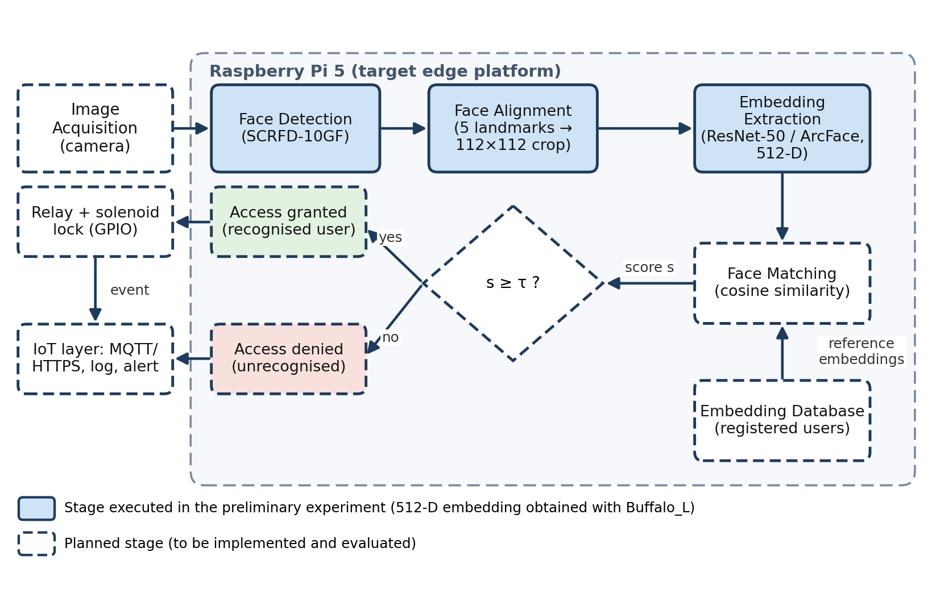
Figure 1.1: Block diagram of the proposed smart access control system
The system works in two phases. In the enrolment phase, one or more images of each authorised person are captured, their embeddings are extracted and stored in a database of reference embeddings. In the verification phase, which runs continuously at the door, the following steps are executed:
- The camera captures a frame, and the face detector looks for a face in it. If none is found, the system waits for the next frame.
- The detected face is aligned to a standard 112×112 crop using its facial landmarks.
- The Buffalo_L recognition network converts the aligned face into a 512-dimensional embedding.
- The embedding is compared with every stored reference embedding using cosine similarity, and the highest score is retained.
- The score is compared with the similarity threshold. If it reaches the threshold, the person is considered recognised.
- For a recognised person, a relay-driven solenoid lock is released for a fixed time. For an unrecognised person, the door stays locked and the attempt is recorded.
- Both outcomes are logged, and a notification is sent through an IoT channel such as MQTT or HTTPS.

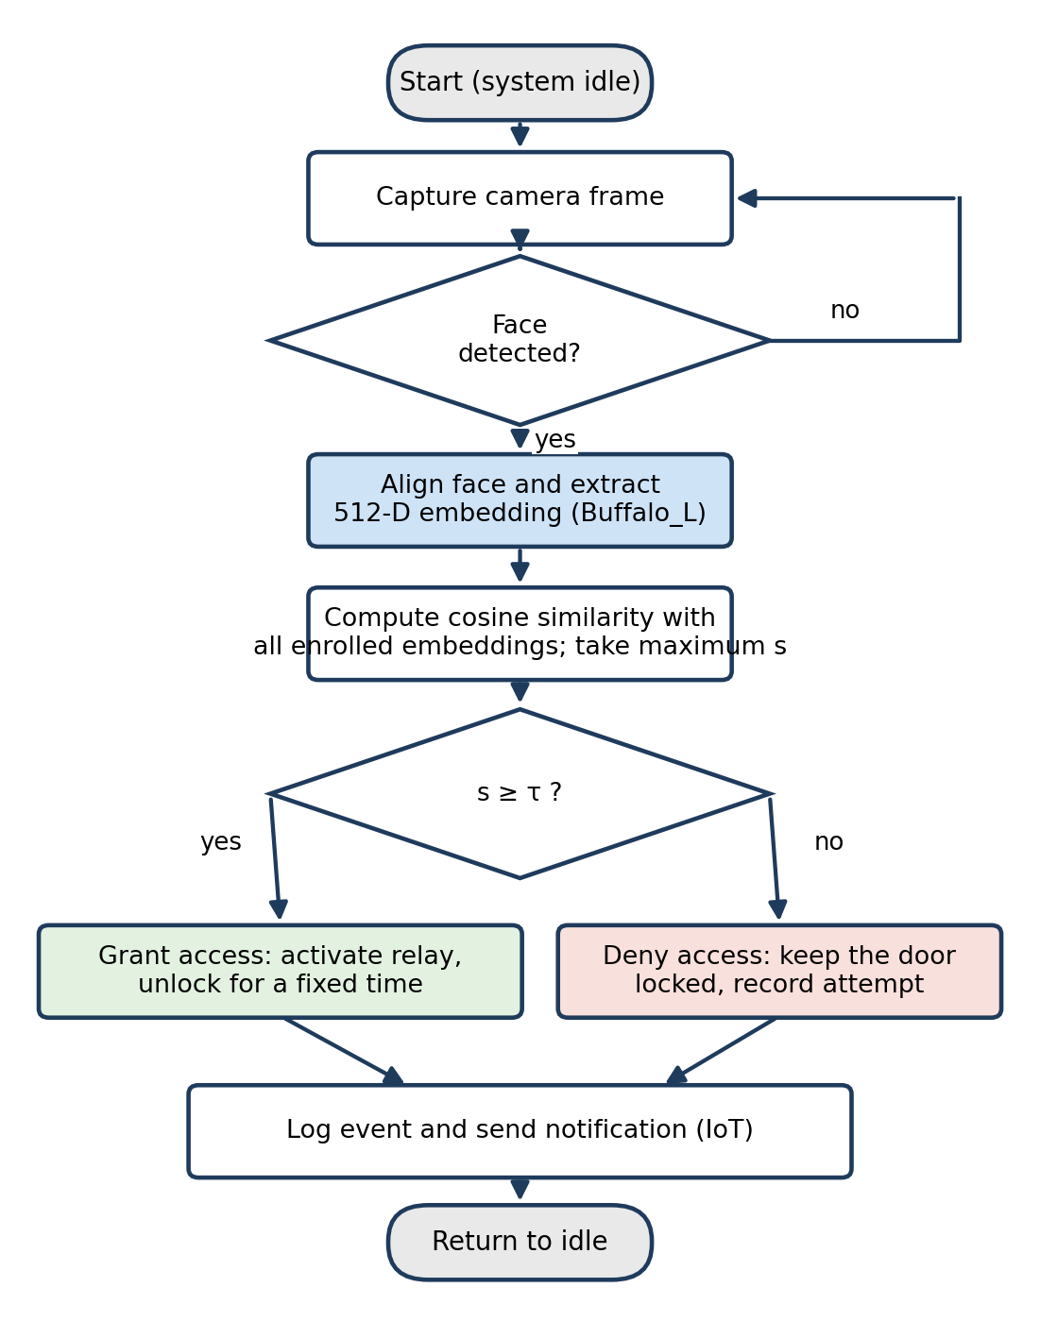
Figure 1.2: Flow chart of one verification cycle
Three design principles guide the solution. First, no model is trained from scratch: a pre-trained recognition model is reused, which removes the need for a large labelled dataset and long training times. Second, the system is edge-first: images are processed on the device, so biometric data does not have to leave the premises and the system keeps working without a cloud connection. Third, the design is modular: detection, embedding, matching, decision and actuation are separate stages, so a stage can be replaced, for example by a lighter recognition model, without redesigning the rest.

1.4.2 Expected Contribution
The expected contribution of the project is a framework that combines face recognition with an intelligent access control concept on an embedded platform. It explores the use of a pre-trained deep learning model to obtain facial embeddings without training a new model, and it establishes a basis for studying facial similarity measurement, decision-threshold selection, and the feasibility of deploying a modern recognition model on a Raspberry Pi 5. The final contribution will depend on the implementation and the evaluation results obtained in the next stages of the project.

1.4.3 Current Status of the Work
Table 1.1 summarises what has been confirmed so far and what remains to be done.
Table 1.1: Status of the project stages
Stage | Status
Face detection and alignment (InsightFace pipeline) | Executed inside the InsightFace pipeline during the preliminary experiment
Face embedding extraction with Buffalo_L (512-D) | Completed in the preliminary experiment
Enrolment and reference embedding database | Planned
Face matching with cosine similarity | Planned
Threshold calibration (false acceptance / false rejection) | Planned
Deployment and benchmarking on Raspberry Pi 5 | Planned
Relay, solenoid lock and IoT integration | Planned

1.5 Beneficiaries of the Research
The proposed system, and the evaluation results that will accompany it, may benefit several groups:
- Educational institutions that need an affordable, intelligent way to control access to laboratories and offices.
- Offices and facilities that require identity verification at entrances without cards or keys.
- Researchers and students working on artificial intelligence and IoT applications, who can reuse the pipeline and the evaluation methodology.
- Developers interested in deploying face recognition systems on embedded platforms, who need measured data on accuracy, latency and resource use.

1.6 Thesis Organization
This document contains the first part of the project report, organised in three chapters, and the plan for the remaining chapters:
- Chapter One: Introduction presents the background, the scientific problem, the objectives, the proposed solution idea, the expected contribution and the beneficiaries.
- Chapter Two: Theoretical Study explains the concepts and technologies on which the project relies: deep learning, face detection and alignment, face embeddings, matching and thresholds, performance metrics, IoT protocols, the Raspberry Pi 5 and electronic locking.
- Chapter Three: Literature Review reviews three recent studies on face recognition door-lock systems, compares them, and identifies the research gap.
- Chapter Four: Research Methodology (planned) will describe the implemented pipeline, the data used for evaluation and the experimental procedure.
- Chapter Five: Research Results (planned) will present the evaluation metrics, the measured results on the Raspberry Pi 5 and the comparison with previous work.
- Chapter Six: Conclusion (planned) will summarise the findings, the challenges and the future directions.

Chapter Two: Theoretical Study
This chapter presents the theoretical concepts on which the project depends and that are needed during its implementation. It starts from the general ideas of machine learning and neural networks, moves through the stages of a face recognition pipeline (detection, alignment, embedding, matching and decision), and ends with the hardware, communication and actuation concepts that are needed to turn a recognition result into a physical access decision.

2.1 Artificial Intelligence, Machine Learning and Deep Learning
Artificial Intelligence (AI) is the field of computer science concerned with building systems that perform tasks that normally require human intelligence, such as perceiving images, recognising patterns, classifying objects and making decisions. Machine Learning (ML) is a branch of AI in which a system learns patterns from data instead of being programmed with explicit rules. Deep Learning (DL) is a subfield of ML that uses artificial neural networks with many layers; each layer transforms the output of the previous one, so the network learns increasingly abstract representations directly from raw data [1], [6].
Deep learning is the dominant approach in computer vision, including face detection and face recognition. In this project it is used in an inference-only manner: a model that was trained beforehand by its authors is loaded and applied to new images, while no training takes place.

2.2 Convolutional and Residual Neural Networks
A Convolutional Neural Network (CNN) is a neural network specialised for grid-like data such as images. Its main building block is the convolutional layer, in which small learnable filters slide over the image and respond to local patterns such as edges and textures. Stacking many convolutional layers, interleaved with non-linear activation functions and down-sampling operations, produces a hierarchy of features: early layers capture edges, middle layers capture parts such as eyes and noses, and deeper layers capture holistic face characteristics [6].
Very deep networks are difficult to optimise. Residual networks (ResNets) solve this by adding shortcut connections that let each block learn a correction to its input instead of a completely new transformation, which makes it practical to train networks with tens or hundreds of layers [7]. The recognition network used by the Buffalo_L model pack has a 50-layer residual backbone (ResNet-50) and is described in Section 2.6.

2.3 Biometric Recognition and Face Recognition
Biometric recognition identifies or verifies a person from physiological or behavioural characteristics [3]. Face Recognition is a computer vision technology that does this from facial appearance. Two operating modes are distinguished:
- Verification (1:1). The system checks a claimed identity by comparing the probe face with the single stored reference of the claimed person.
- Identification (1:N). The system compares the probe face with all N stored references and returns the best match, or reports that the person is unknown. When people who are not registered may also appear, as at a door, this is called open-set identification, and a rejection threshold is essential.

A modern face recognition system is organised as a pipeline: detect the face, align it to a canonical pose, represent it as an embedding, match the embedding against references, and finally decide using a threshold [4]. The main difficulties are variations in pose, illumination, facial expression, occlusion (glasses, masks) and ageing. The system proposed in this project performs open-set identification among a small set of registered users.

2.4 Face Detection
Face Detection is the process of determining whether a face is present in an image and where. The location is usually expressed as a bounding box in image coordinates, often together with a confidence score and a small set of facial landmarks (typically the two eyes, the nose tip and the two mouth corners). Detection is the first stage of the pipeline, because it isolates the region that the later stages process.
Face detection methods have evolved considerably. The Viola–Jones detector uses Haar-like features and a cascade of boosted classifiers and runs fast on weak hardware [8]. Histogram of Oriented Gradients (HOG) features combined with a linear classifier give a more robust hand-crafted alternative [9]. Deep learning detectors such as MTCNN [10], RetinaFace [11] and SCRFD [12] are considerably more accurate on difficult images, with different cost–accuracy trade-offs. The Buffalo_L pack uses SCRFD with a computation budget of 10 GFLOPs, which outputs boxes and five landmarks for each face.

2.5 Face Alignment
Face Alignment normalises the geometry of the face before feature extraction. Using the landmarks, a similarity transformation (rotation, uniform scaling and translation) is estimated that maps the detected landmarks to a fixed template, and the image is warped accordingly. For a point p = (x, y) the transformation is
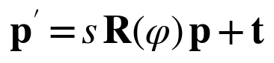 (2.1)
where p′ is the transformed point, s the scale factor, R(φ) the 2×2 rotation matrix for the angle φ (with rows (cos φ, −sin φ) and (sin φ, cos φ)), and t the translation vector. The result is a face crop of fixed size, typically 112×112 pixels for ArcFace-type models, in which the eyes and mouth are always in the same place. Alignment removes in-plane rotation and scale variation, so the recognition network only has to deal with the remaining variability. The exact alignment procedure depends on the model and implementation.

2.6 Pre-trained Models and the InsightFace Buffalo_L Pack
A pre-trained model is a model that was trained beforehand on a large dataset and is reused for a related task, without training a new model from scratch. This saves development time and computing resources and gives access to models trained on data volumes that a student project could not collect. Its suitability for a specific platform, however, must still be verified by testing.
InsightFace is an open-source 2D and 3D face analysis project that provides detection, landmark, recognition and attribute models [5]. Its Buffalo_L model pack, used in this project, is a bundle of five networks (Table 2.1). In the InsightFace model zoo the pack is listed as combining an SCRFD-10GF detector with a ResNet-50 recognition model trained on the WebFace600K dataset, with a total size of about 326 MB [5].
Table 2.1: Components of the InsightFace Buffalo_L model pack
File | Task | Remarks
det_10g.onnx | Face detection | SCRFD with a 10 GFLOPs budget; outputs boxes, scores, 5 landmarks
2d106det.onnx | 2D facial landmarks | 106 points; used for alignment and face analysis
1k3d68.onnx | 3D facial landmarks | 68 points; head-pose estimation
w600k_r50.onnx | Face recognition (core) | ResNet-50 trained on WebFace600K; 512-D embedding from an aligned 112×112 face
genderage.onnx | Attribute analysis | Gender and age estimation; not needed for access control

For an access control application only the detector and the recognition network are essential. Gender and age estimation and the 3D landmarks are not needed, and disabling unused modules is one optimisation that will be evaluated on the Raspberry Pi 5.

2.7 Face Embeddings and Metric Learning
A Face Embedding is a numerical vector that represents the characteristics of a face extracted from an image. Instead of comparing raw pixels, which change with lighting and pose, a recognition system compares the embeddings of different images. In the preliminary experiment of this project, the selected model produced an embedding of 512 numerical values for a face image. Extracting an embedding alone, however, does not establish a person's identity: a separate comparison procedure and reference embeddings are required.
Embeddings are usually normalised to unit length so that only their direction matters:
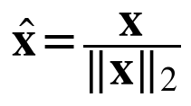 (2.2)
where x is the raw output vector and ‖·‖₂ the Euclidean norm. The quality of an embedding depends on the loss function used during training, which is an example of metric learning: the network is trained so that embeddings of the same person are close and embeddings of different people are far apart. The standard softmax cross-entropy loss over n identities is
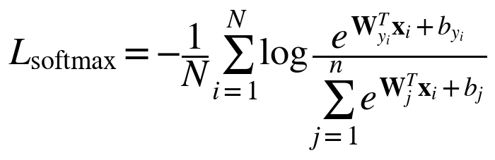 (2.3)
where x_{i} is the feature of the i-th sample, y_{i} its identity label, W_{j} and b_{j} the weight vector and bias of class j, and N the batch size. Softmax separates identities but does not explicitly force compact classes. Margin-based losses such as CosFace [13] and ArcFace [14] add a margin between classes. ArcFace works on the angle θ_{j} between the normalised feature and the normalised class weight, and adds an angular margin m to the angle of the correct class:
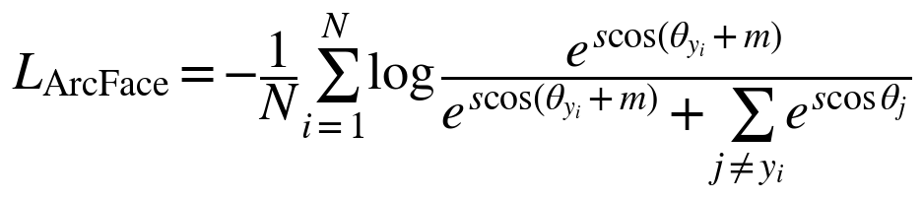 (2.4)
where s is a scale factor. Because the margin is applied directly to an angle, it has a clear geometric meaning on the unit hypersphere, and it pushes the embeddings of one person into a narrow cone while separating different people [14]. This is why the cosine similarity of ArcFace-type embeddings is a meaningful measure of identity. Since the Buffalo_L recognition model is pre-trained, these losses are not evaluated in this project; they are presented to explain why the model's embeddings can be compared with a simple angular measure.

2.8 Face Matching
Face Matching compares two embeddings to quantify their similarity. In a typical system, the embedding extracted from a new image is compared with the embeddings stored for registered people. A widely used measure is the cosine similarity, which is the cosine of the angle between two vectors:
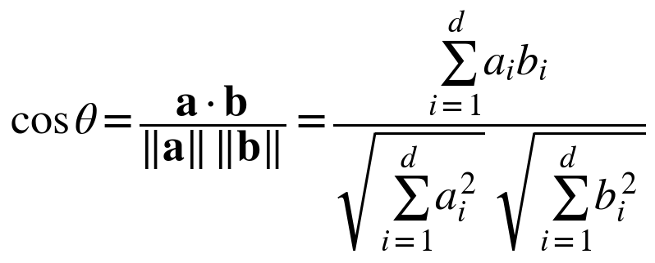 (2.5)
The value lies in [−1, 1]; higher values mean that the faces are more alike. For embeddings normalised as in Equation (2.2), the cosine similarity reduces to a dot product, and it is directly related to the Euclidean distance between the embeddings:
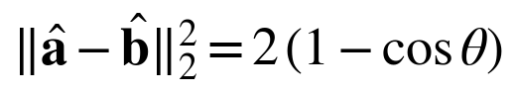 (2.6)
so ranking by cosine similarity and ranking by Euclidean distance give the same order for normalised vectors. In identification mode, the probe embedding is compared with all N reference embeddings, and the identity with the highest score is the candidate. A 512-dimensional float32 embedding occupies 2 KB, so even hundreds of registered users can be searched with a simple exhaustive comparison that costs a negligible fraction of the total processing time. The implementation of this stage requires a comparison routine and suitable reference data, which are part of the planned work.

2.9 Similarity Threshold and Performance Metrics
A Similarity Threshold τ is the decision boundary that turns the best similarity score s into an accept or reject decision:
(2.7)
Depending on the similarity measure used, scores above or below the threshold indicate a match; with cosine similarity, higher is better. Two kinds of error exist, summarised in Table 2.2. A false acceptance admits a person who should not enter, which is a security failure. A false rejection turns away a legitimate user, which is an inconvenience.
Table 2.2: Possible outcomes of an access decision
 | Decision: accept | Decision: reject
Legitimate (registered) person | True acceptance | False rejection
Impostor (not registered) | False acceptance | True rejection

The corresponding rates are the False Acceptance Rate (FAR) and the False Rejection Rate (FRR) [3]:
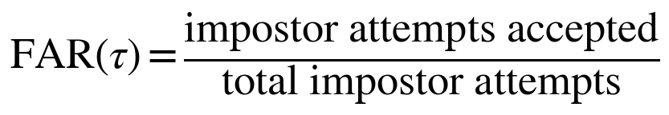 (2.8)
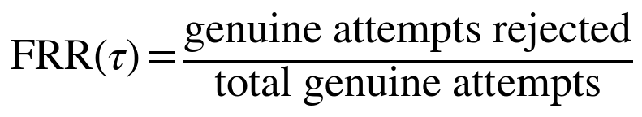 (2.9)
Raising τ lowers the FAR and raises the FRR, and lowering it does the opposite (Figure 2.1). The Receiver Operating Characteristic (ROC) curve plots the true acceptance rate against the FAR for all thresholds, and the Equal Error Rate (EER) is the point where FAR equals FRR. For a door, the operating point is normally chosen at a low FAR, accepting a somewhat higher FRR.
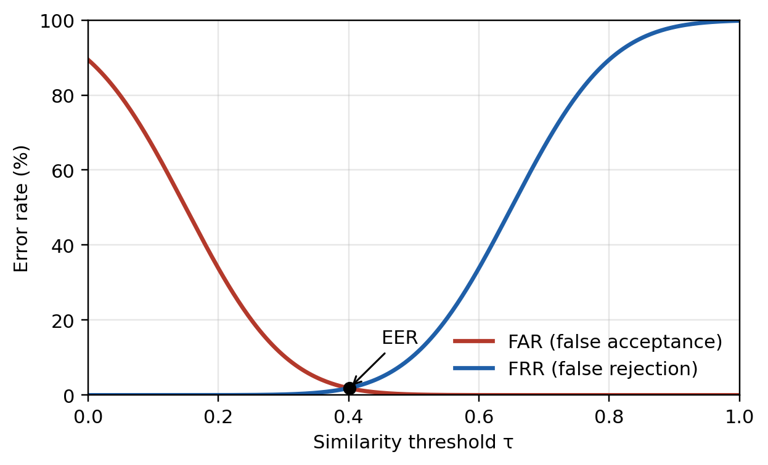
Figure 2.1: Schematic trade-off between FAR and FRR as a function of the threshold (illustrative curves, not measured data)
A threshold must not be selected arbitrarily, nor assumed to be reliable without experimental validation. It has to be determined by testing with data that represent the real deployment conditions (camera position, lighting, users), which is part of the planned methodology.

2.10 Security and Privacy Considerations
A face recognition system can be attacked by presenting a photograph, a video or a mask in front of the camera. These are called presentation attacks, and the countermeasure is presentation attack detection, or liveness detection, whose testing and reporting are standardised in ISO/IEC 30107-3 [15]. A pipeline that only computes embeddings, as in this project's baseline, does not include such protection, and this limitation must be stated whenever results are reported.
Facial data are sensitive personal data. Good practice includes processing images locally, storing embeddings instead of raw photographs, protecting the database and the communication channel with encryption, obtaining the consent of enrolled users, and keeping a log of access events. The edge-first design of the project follows these principles.

2.11 Internet of Things and Communication Protocols
The Internet of Things (IoT) is a network of physical devices that sense, process and exchange data through communication technologies. It allows an intelligent device such as the recognition unit to be connected with monitoring platforms, mobile applications and automatic control mechanisms. In this project, IoT technologies are intended for sending notifications, logging events and, optionally, remote supervision. Table 2.3 lists the technologies that may be relevant.
Table 2.3: Communication technologies relevant to the project
Technology | Role | Characteristics
Wi-Fi | Wireless network access | Common, sufficient bandwidth, built into the Raspberry Pi
Bluetooth | Short-range wireless link | Low power; suitable for nearby phones or sensors
TCP/IP | Basic transport and addressing | Reliable, connection-oriented foundation of most IoT protocols
MQTT | Publish/subscribe messaging | Lightweight; broker-based; three quality-of-service levels; suited to events and notifications [16]
HTTP/HTTPS | Web client–server requests | Widely supported; HTTPS adds transport encryption

The protocols that are actually needed depend on the final architecture, and not all of them will be implemented in the project.

2.12 Raspberry Pi 5 and Embedded Inference
The Raspberry Pi 5 is a compact single-board computer for computing, prototyping and embedded applications [17]. It has a quad-core 64-bit Arm Cortex-A76 processor running at up to 2.4 GHz, a 40-pin general-purpose input/output (GPIO) header, camera and USB interfaces, and wired and wireless networking. It has no dedicated neural accelerator, so the deep learning models run on the CPU unless an optional accelerator is added.
Models distributed in ONNX format can be executed on such a CPU with ONNX Runtime [18], which is also the runtime used by the InsightFace Python package. Whether the Buffalo_L pack runs acceptably on the Raspberry Pi 5 depends on software compatibility, available memory, processing power and inference time, and must therefore be evaluated experimentally before the board is adopted as the final platform. The quantities to be measured are the latency of each stage, the end-to-end latency, the throughput in frames per second, the memory consumption, the CPU load and the board temperature, since sustained load may trigger thermal throttling. The end-to-end latency perceived by a person at the door is the sum of the stage latencies:
(2.10)
where the terms are the times for capture, detection, alignment, embedding extraction, matching and lock actuation respectively.

2.13 Electronic Locking and Actuation
The recognition result must finally move a lock. A GPIO pin of the Raspberry Pi works at 3.3 V and can supply only a few milliamperes, so it cannot drive a lock coil directly. A relay module (or a transistor driver) acts as an electronically controlled switch between the board and a separate power supply for the lock. An electric solenoid lock is a common choice in door-lock prototypes [2], [20]. Because a solenoid is an inductive load, a flyback diode is normally fitted across it to protect the switching element.
The behaviour of the lock when power or software fails is a safety decision. A fail-secure lock stays locked, which protects the room, while a fail-safe lock unlocks, which protects people during an emergency. The choice, together with a manual exit option, must be made according to the place where the system is used.

2.14 Chapter Summary
This chapter covered the theory behind each stage of the proposed system, from neural networks and the ArcFace-type embedding model to cosine matching, the threshold and FAR/FRR trade-off, security, IoT protocols, the Raspberry Pi 5 and the electronic lock. The next chapter reviews how recent research has applied these ideas.

Chapter Three: Literature Review
Objective. This chapter shows what recent research has already achieved in face recognition-based access control, identifies the strengths and weaknesses of existing work, and demonstrates that the proposed project addresses a real gap. It reviews three recent studies (2023–2026) on face recognition door-lock systems.

3.1 Introduction and Scope of the Review
The three studies in this chapter were selected because they combine face recognition with an electronic door lock or an access decision. They are limited to publications from the last four years (2023–2026). The review is not a systematic literature review. The details reported below were taken from the published summaries of the studies; where a detail was not available in the material read, this is stated instead of being guessed.

3.2 Previous Studies in Similar Domains
D. Naresh et al. (2026) [19]. The authors present an AI-based smart door lock that combines face recognition with Internet of Things (IoT) integration. The system detects faces, preprocesses the captured images and extracts unique facial features automatically, using Python, AI/ML libraries and computer vision tools. The authors conclude that the approach enhances security, automation and reliability. The strength of the work is its automated pipeline, from detection to feature extraction, within an IoT framework. Its limitation, in the material reviewed, is that the recognition algorithm, the hardware platform and any quantitative accuracy or latency figures are not specified, so the claimed improvements cannot be compared numerically with the other studies.
Zoha et al. (2025) [2]. A group at Universiti Teknikal Malaysia Melaka, with a co-author from the University of Hertfordshire, built an IoT door lock that combines face recognition with fire safety. The system uses a Raspberry Pi, a Pi camera, a solenoid lock and a flame sensor, and it is connected through Google Firebase to a mobile application that supports remote lock control, face enrolment and notifications. Recognition uses the face_recognition library: faces are detected with HOG, encoded as 128-dimensional vectors, and matched by Euclidean distance. On detecting flame, the system sends an alert and unlocks the door for evacuation. The reported results are a known-face success rate of 100%, an unknown-face success rate of 99.51%, and an area under the ROC curve of 1.00. Its strengths are the integrated safety function, the remote management and the explicit evaluation formulas. The paper, however, does not report the size or composition of the test set or the lighting conditions, the success rates are computed over frames, and a perfect AUC on an undisclosed test set should be interpreted with caution. It also uses an older-generation 128-D descriptor and does not mention protection against photograph attacks.
Kumar et al. (2023) [20]. The authors propose a customised smart door-unlocking system that uses face recognition on a Raspberry Pi platform, motivated by the weaknesses of PIN, Bluetooth and Wi-Fi based locks, and published the work in the E3S Web of Conferences (ICMED-ICMPC 2023). The system uses a Raspberry Pi board and a camera module; it extracts facial features from the captured image, compares them with stored face templates, and drives a solenoid lock. The database of authorised people is kept in the cloud, and the owner manages entry and exit through a mobile application. The reported accuracy is 95.3%. The strength of the work is its complete concept (recognition, cloud database, remote management); its limitation is that the accuracy is given as a single figure, without a described test set or decision threshold in the material reviewed.
Table 3.1 summarises the reviewed studies.
Table 3.1: Summary of the reviewed studies
Study | Authors / year | Paper objective | Adopted principle | Tools used | Key findings
Face recognition door lock system with IoT and AI | Naresh et al., 2026 | AI-based smart door lock using face recognition and IoT integration | Detect faces, preprocess images, and extract unique facial features automatically | Python, AI/ML libraries, computer vision tools | Enhances security, automation and reliability
The development of IoT-based smart door lock and fire alert system using facial recognition | Zoha et al., 2025 | Develop an IoT home security system that integrates facial recognition technology | Histogram of oriented gradients (HOG) method | Raspberry Pi, Raspberry Pi camera, solenoid door lock, flame sensor | Known-face detection success rate 100%; unknown-face detection success rate 99.51%
Face recognition and Raspberry Pi powered smart door unlocking system | Kumar et al., 2023 | A customised smart door-unlocking system that uses face recognition on a Raspberry Pi platform | Extracts facial features and compares them with the stored face templates | Raspberry Pi board, camera module, face recognition algorithm | Accuracy of 95.3%

3.3 Comparative Analysis of Systems
Table 3.2 compares the three door-lock systems reviewed with the system proposed in this project, in terms of technique, hardware, reported performance and limitations.
Table 3.2: Comparison of existing systems and the proposed system
System | Recognition technique | Hardware / actuation | Reported performance | Main limitations
Naresh et al. (2026) | Automatic face detection, image preprocessing and facial feature extraction (Python, AI/ML libraries) | IoT-integrated smart door lock; hardware not specified | No quantitative result in the reviewed material (enhanced security, automation, reliability) | Algorithm, hardware and accuracy not specified
Zoha et al. (2025) | HOG detection, 128-D encodings, Euclidean distance | Raspberry Pi, solenoid lock, flame sensor, Firebase app | Known 100%, unknown 99.51%, AUC 1.00 | Test-set size and conditions not reported; older descriptor; cloud-dependent remote functions
Kumar et al. (2023) | Facial feature extraction and comparison with stored face templates | Raspberry Pi, camera module, solenoid lock, cloud database, mobile app | Accuracy 95.3% | Single accuracy figure; test set and threshold not described
Proposed system | Buffalo_L: SCRFD detector + ArcFace ResNet-50 embeddings, cosine similarity | Raspberry Pi 5 (target), relay and solenoid lock, MQTT (planned) | To be measured | Large model (about 326 MB) on embedded CPU; no liveness detection in the baseline

3.4 Research Gap and Proposed Innovation
Based on the studies reviewed in this chapter, the following gaps can be identified:
- Older or unspecified recognition methods. The reviewed door-lock systems rely on HOG detection with 128-D encodings, or do not name a deep embedding model; none of them is described as using an ArcFace-class embedding model with a margin-based loss, although such models are the current standard for deep face recognition.
- Incomplete evaluation reporting. Accuracy figures are often given without the size and composition of the test set, the lighting conditions or the decision threshold, and the trade-off between false acceptance and false rejection is rarely analysed, even though it is the central question for an access control system.
- Little measured resource data. None of the studies reviewed reports latency, or the memory and CPU consumption of a modern recognition model on a Raspberry Pi 5.
- Security. Protection against presentation attacks is not described in the studies reviewed.

The proposed project addresses the first three of these points. It uses a pre-trained ArcFace-class embedding model (InsightFace Buffalo_L) in an edge pipeline, studies how the similarity threshold determines the FAR/FRR trade-off, and measures the accuracy, latency and resource consumption of the pipeline on the Raspberry Pi 5. Liveness detection is outside the scope of the baseline system and is considered a future extension.
These gaps are drawn from the studies reviewed here and from the stated scope of the project. They are not a claim that no other work exists, and they should be revisited if further relevant studies are found.

3.5 Chapter Summary
This chapter reviewed three recent studies on face recognition door-lock and access control systems on embedded platforms. The comparison shows that existing prototypes rely on classical or unspecified recognition methods and report incomplete evaluations, and it motivates the evaluation of an ArcFace-class embedding model on the Raspberry Pi 5 with a measured study of the threshold and of resource consumption. The next chapters of the report will describe the methodology and present the measured results.

References
[1] Y. LeCun, Y. Bengio, and G. Hinton, “Deep learning,” Nature, vol. 521, no. 7553, pp. 436–444, 2015.
[2] M. S. Zoha, N. A. Moketar, M. Kamalrudin, S. Akmal, S. F. Pratama, and A. H. Mazbah, “The development of IoT based smart door lock and fire alert system using facial recognition,” J. Adv. Comput. Technol. Appl. (JACTA), vol. 7, no. 1, pp. 1–15, 2025, doi: 10.54554/jacta.2025.07.01.001.
[3] A. K. Jain, A. Ross, and S. Prabhakar, “An introduction to biometric recognition,” IEEE Trans. Circuits Syst. Video Technol., vol. 14, no. 1, pp. 4–20, 2004.
[4] M. Wang and W. Deng, “Deep face recognition: A survey,” Neurocomputing, vol. 429, pp. 215–244, 2021, doi: 10.1016/j.neucom.2020.10.081.
[5] InsightFace Project, “InsightFace: 2D and 3D face analysis project,” GitHub repository. [Online]. Available: https://github.com/deepinsight/insightface (accessed Oct. 28, 2026).
[6] I. Goodfellow, Y. Bengio, and A. Courville, Deep Learning. Cambridge, MA, USA: MIT Press, 2016.
[7] K. He, X. Zhang, S. Ren, and J. Sun, “Deep residual learning for image recognition,” in Proc. IEEE Conf. Comput. Vis. Pattern Recognit. (CVPR), 2016, pp. 770–778.
[8] P. Viola and M. Jones, “Rapid object detection using a boosted cascade of simple features,” in Proc. IEEE Conf. Comput. Vis. Pattern Recognit. (CVPR), 2001, vol. 1, pp. I-511–I-518.
[9] N. Dalal and B. Triggs, “Histograms of oriented gradients for human detection,” in Proc. IEEE Conf. Comput. Vis. Pattern Recognit. (CVPR), 2005, vol. 1, pp. 886–893.
[10] K. Zhang, Z. Zhang, Z. Li, and Y. Qiao, “Joint face detection and alignment using multitask cascaded convolutional networks,” IEEE Signal Process. Lett., vol. 23, no. 10, pp. 1499–1503, 2016.
[11] J. Deng, J. Guo, E. Ververas, I. Kotsia, and S. Zafeiriou, “RetinaFace: Single-shot multi-level face localisation in the wild,” in Proc. IEEE/CVF Conf. Comput. Vis. Pattern Recognit. (CVPR), 2020, pp. 5203–5212.
[12] J. Guo, J. Deng, A. Lattas, and S. Zafeiriou, “Sample and computation redistribution for efficient face detection,” in Proc. Int. Conf. Learn. Represent. (ICLR), 2022, arXiv:2105.04714.
[13] H. Wang et al., “CosFace: Large margin cosine loss for deep face recognition,” in Proc. IEEE/CVF Conf. Comput. Vis. Pattern Recognit. (CVPR), 2018, pp. 5265–5274.
[14] J. Deng, J. Guo, J. Yang, N. Xue, I. Kotsia, and S. Zafeiriou, “ArcFace: Additive angular margin loss for deep face recognition,” IEEE Trans. Pattern Anal. Mach. Intell., vol. 44, no. 10, pp. 5962–5979, 2022, arXiv:1801.07698.
[15] Information Technology — Biometric Presentation Attack Detection — Part 3: Testing and Reporting, ISO/IEC 30107-3, International Organization for Standardization, Geneva, Switzerland.
[16] OASIS, “MQTT Version 5.0,” OASIS Standard, Mar. 2019. [Online]. Available: https://docs.oasis-open.org/mqtt/mqtt/v5.0/mqtt-v5.0.html
[17] Raspberry Pi Ltd., “Raspberry Pi documentation.” [Online]. Available: https://www.raspberrypi.com/documentation/ (accessed Oct. 28, 2026).
[18] ONNX Runtime Developers, “ONNX Runtime: Cross-platform, high performance ML inferencing and training accelerator.” [Online]. Available: https://onnxruntime.ai/ (accessed Oct. 28, 2026).
[19] D. Naresh, P. Anand, M. Harish, A. Vamshi, A. Kethan, B. Nirmala, and M. Saravanan, “Face recognition door lock system with IoT and AI,” 2026.
[20] Y. J. N. Kumar, G. S. Kumar, K. Rishik, D. D. Chaitanya, and S. Charan, “Face recognition and Raspberry Pi powered smart door unlocking system,” E3S Web Conf., vol. 391, Art. no. 01087, 2023, doi: 10.1051/e3sconf/202339101087.

